NOTES FROM TOJOBY INVESTIGATION

Investigative reporter Toby Majox was investigating the disappearance of reclusive developer Max Tojoby. Upon receiving a tip that Tojoby was seen at a meditation retreat, Toby was led to his room…
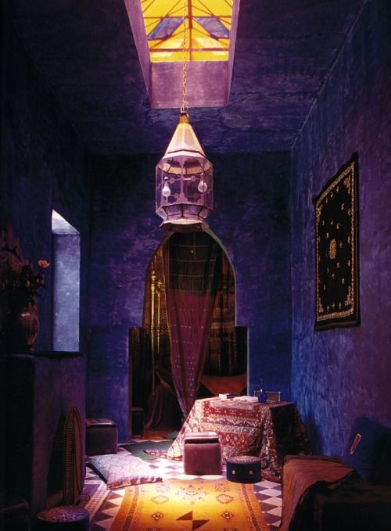

He entered, only to find it empty with only a few personal items left behind.

- A child’s animal puzzle, with pieces hidden everywhere in the room
- A torn-out two-page ad for a programming college
- An article in French of unknown origin
- A trivia quiz from a child’s magazine
- Inside a child’s Toy Box on the scene was:
  - A piece of paper

The whereabouts of Tojoby could not be further determined. Toby is still studying these items to see if any clues are within.

Two days later, a CD containing four zip files arriving at the precinct, labeled only with:
;^)

Look in tbj_mystery to study these clues!

